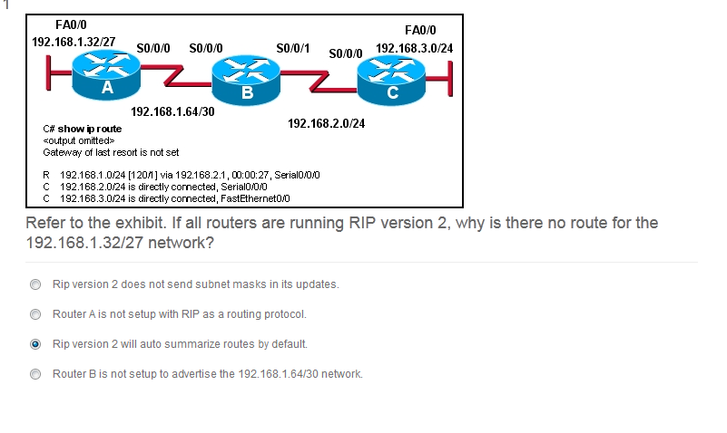

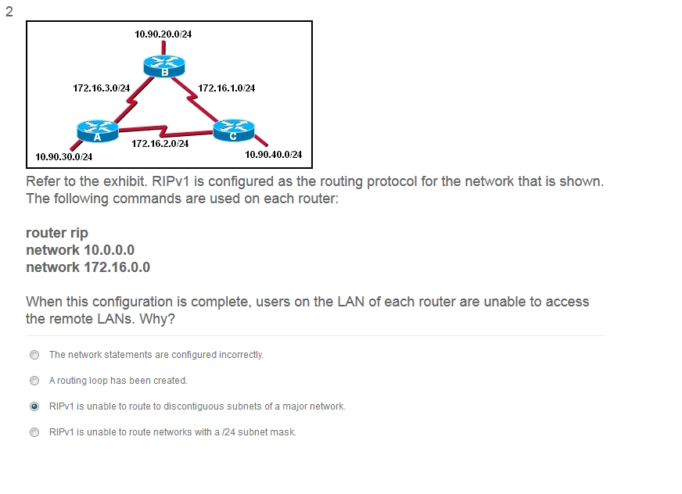

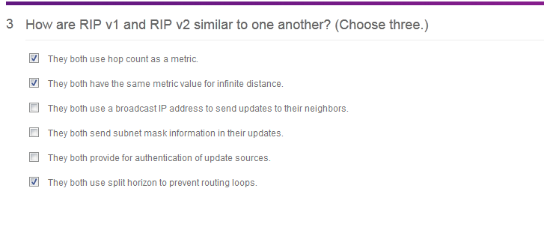

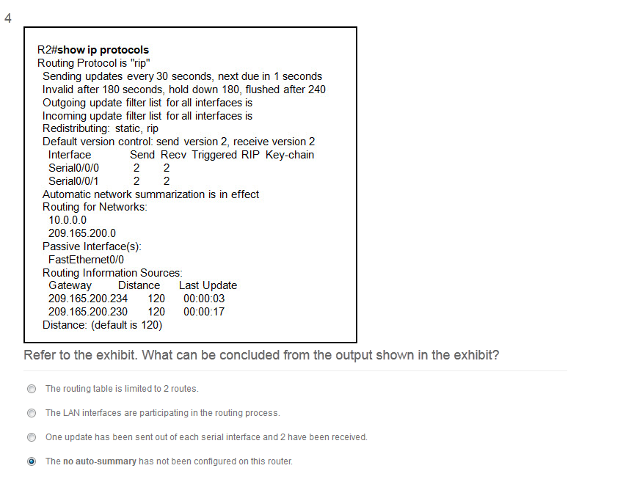

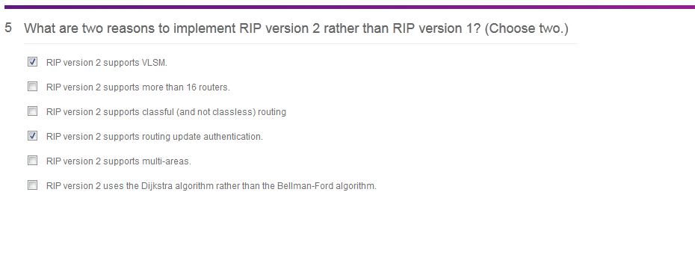

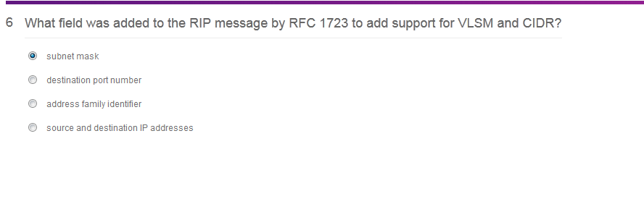

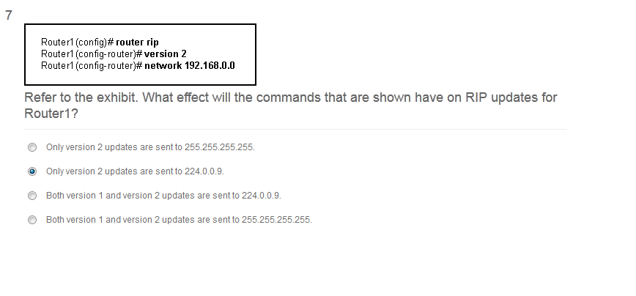

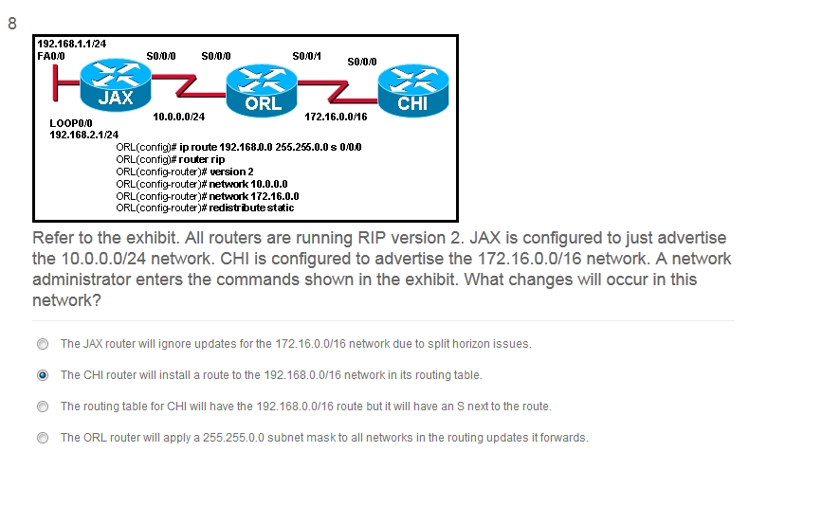

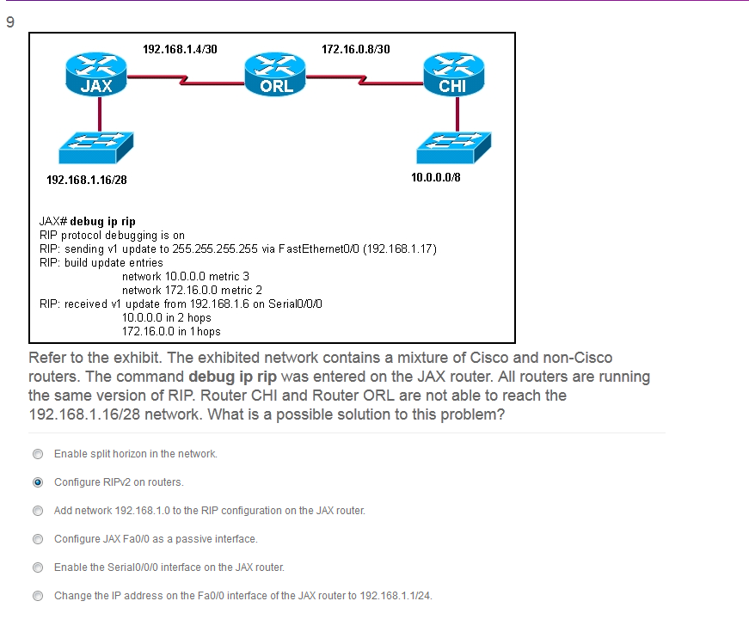

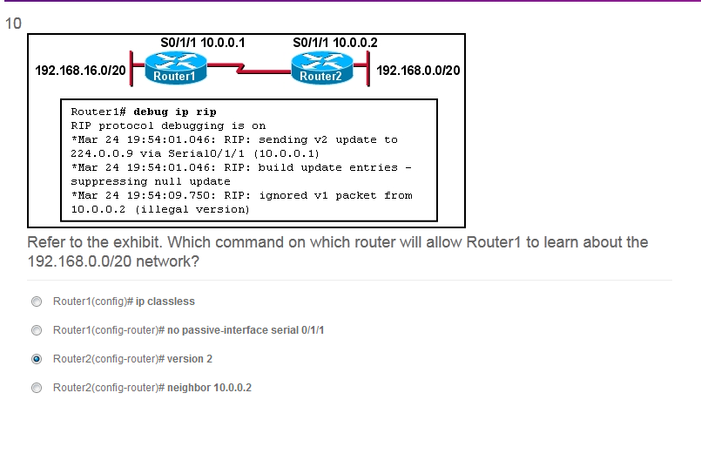

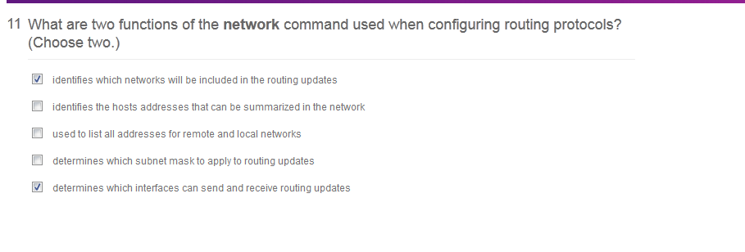

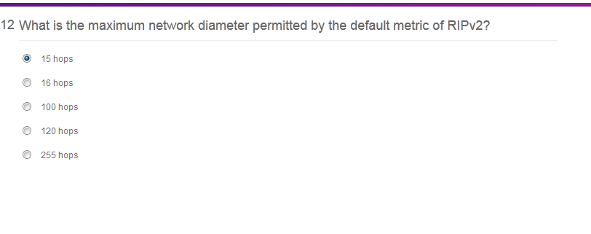

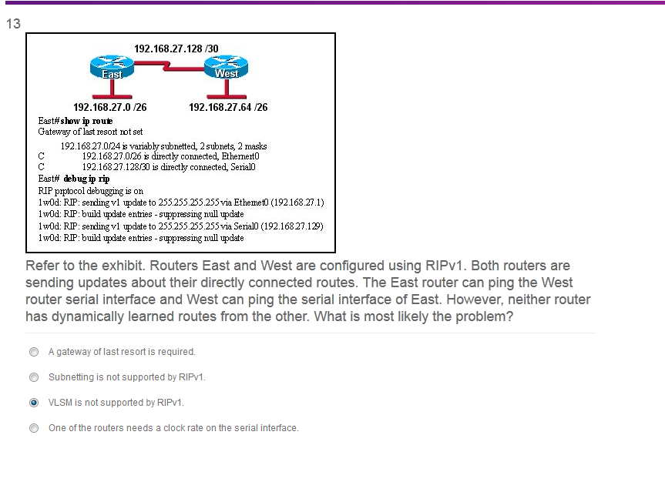

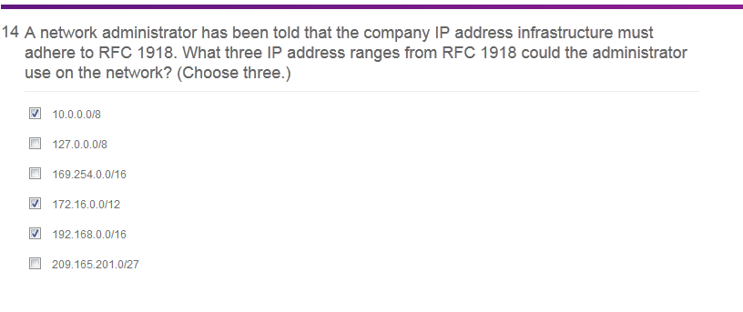

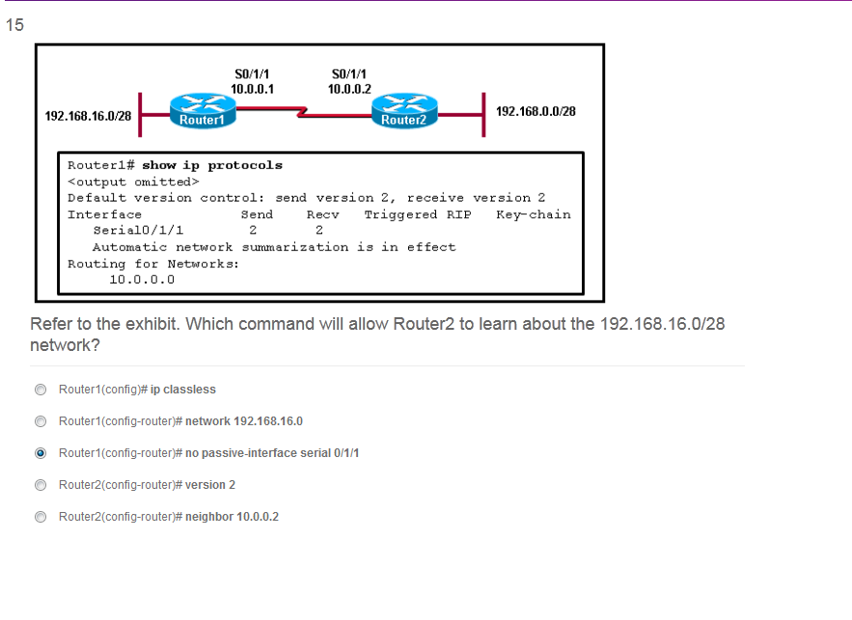

**Refer to the exhibit. Which command will allow Router2 to learn about the 192.168.16.0/28 network**?  
Router1(config)# **ip classless**  
Router1(config-router)# **network 192.168.16.0**  
Router1(config-router)# **no passive-interface serial 0/1/1**  
Router2(config-router)# **version 2**  
Router2(config-router)# **neighbor 10.0.0.2**

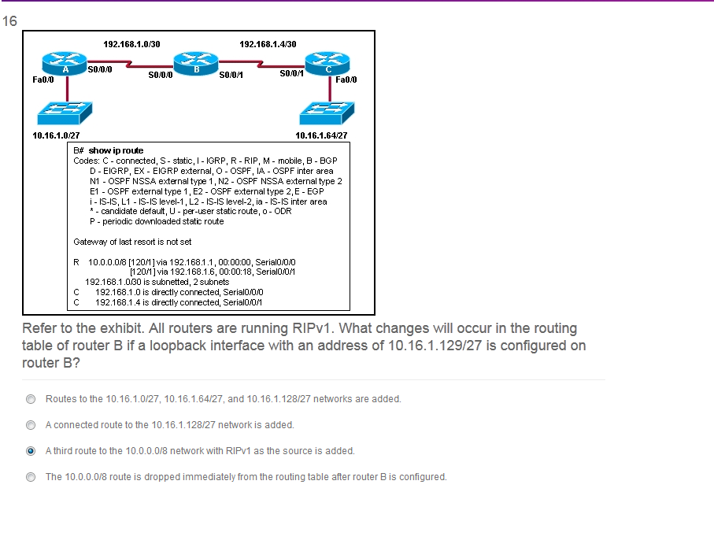

**11**.

[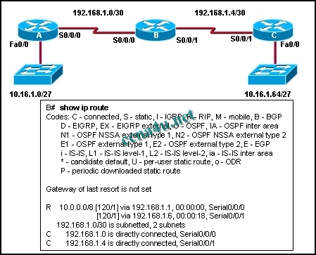](http://answers.ccna4u.net/wp-content/uploads/2011/02/1321.jpg)

**Refer to the exhibit. All routers are running RIPv1. What changes will occur in the routing table of router B if a loopback interface with an address of 10.16.1.129/27 is configured on router B?**  
Routes to the 10.16.1.0/27, 10.16.1.64/27, and 10.16.1.128/27 networks are added.  
A connected route to the 10.16.1.128/27 network is added.  
A third route to the 10.0.0.0/8 network with RIPv1 as the source is added.  
The 10.0.0.0/8 route is dropped immediately from the routing table after router B is configured.

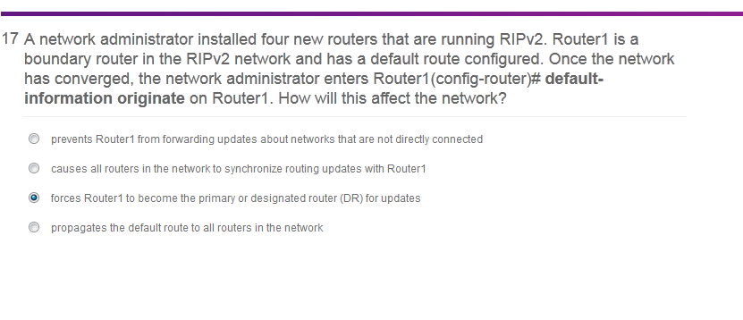

**7**. **A network administrator installed four new routers that are running RIPv2. Router1 is a boundary router in the RIPv2 network and has a default route configured. Once the network has converged, the network administrator enters Router1(config-router)# default-information originate on Router1. How will this affect the network?**  
prevents Router1 from forwarding updates about networks that are not directly connected  
causes all routers in the network to synchronize routing updates with Router1  
forces Router1 to become the primary or designated router (DR) for updates  
propagates the default route to all routers in the network

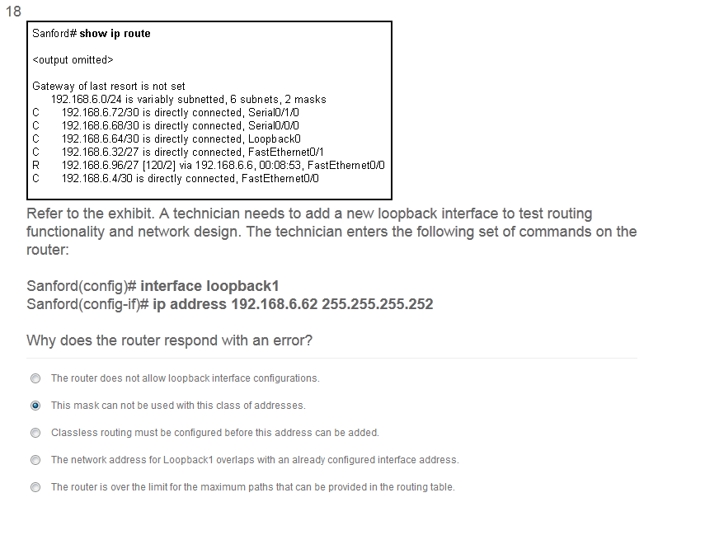

**8**.

[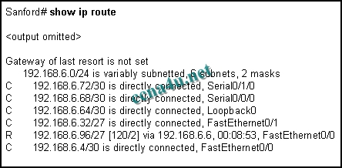](http://answers.ccna4u.net/wp-content/uploads/2011/02/0811.jpg)

**Refer to the exhibit. A technician needs to add a new loopback interface to test routing functionality and network design. The technician enters the following set of commands on the router:**

Sanford(config)# **interface loopback1**

Sanford (config-if)# **ip address 192.168.6.62 255.255.255.252** Why does the router respond with an error?  
The router does not allow loopback interface configurations.  
This mask can not be used with this class of addresses.  
Classless routing must be configured before this address can be added.  
The network address for Loopback1 overlaps with an already configured interface address.  
The router is over the limit for the maximum paths that can be provided in the routing table.

